Differential Gene Expression
If the genome is the same in all somatic cells within an organism (with the exception of the above-mentioned lymphocytes), how do the cells become different from one another? If every cell in the body contains the genes for hemoglobin and insulin proteins, how are the hemoglobin proteins made only in the red blood cells, the insulin proteins made only in certain pancreas cells, and neither made in the kidney or nervous system? Based on the embryological evidence for genomic equivalence (and on bacterial models of gene regulation), a consensus emerged in the 1960s that cells differentiate through differential gene expression. The three postulates of differential gene expression are as follows:
1. Every cell nucleus contains the complete genome established in the fertilized egg. In molecular terms, the DNAs of all differentiated cells are identical.
2. The unused genes in differentiated cells are not destroyed or mutated, and they retain the potential for being expressed.
3. Only a small percentage of the genome is expressed in each cell, and a portion of the RNA synthesized in the cell is specific for that cell type.
The first two postulates have already been discussed. The third postulate—that only a small portion of the genome is active in making tissue-specific products—was first tested in insect larvae. Fruit fly larvae have certain cells whose chromosomes become polytene. These chromosomes, beloved by Drosophila geneticists, undergo DNA replication in the absence of mitosis and therefore contain 512 (2⁹), 1024 (2¹⁰), or even more parallel DNA double helices instead of just one (Figure 4.13A,Figure 4.13B). These cells do not undergo mitosis, and they grow by expanding to about 150 times their original volume. Beermann (1952) showed that the banding patterns of polytene chromosomes were identical throughout the larva, and that no loss or addition of any chromosomal region was seen when different cell types were compared. However, he and others showed that in different tissues, different regions of these chromosomes were making organ-specific RNA. In certain cell types, particular regions of the chromosomes would loosen up, “puff” out, and transcribe mRNA. In other cell types, these regions would be “silent,” but other regions would puff out and synthesize mRNA.
The idea that the genes of chromosomes were differentially expressed in different cell types was confirmed using DNA-RNA hybridization (Figure 4.13C). This technique involves annealing single-stranded pieces of RNA and DNA to allow complementary strands to form double-stranded hybrids. While some mRNAs from one cell type were also found in other cell types (as expected for mRNAs encoding enzymes concerned with cell metabolism), many mRNAs were found to be specific for a particular type of cell and were not expressed in other cell types, even though the genes encoding them were present (Wetmur and Davidson 1968). Thus, differential gene expression was shown to be the way a single genome derived from the fertilized egg could generate the hundreds of different cell types in the body. The question then became, How does this differential gene expression occur? The answers to that question will be the topic of the next chapter. To understand the results that will be presented there, however, one must become familiar with some of the techniques of molecular biology that are being applied to the study of development. These include techniques to determine the spatial and temporal location of specific mRNAs, as well as techniques to determine the functions of these messages.
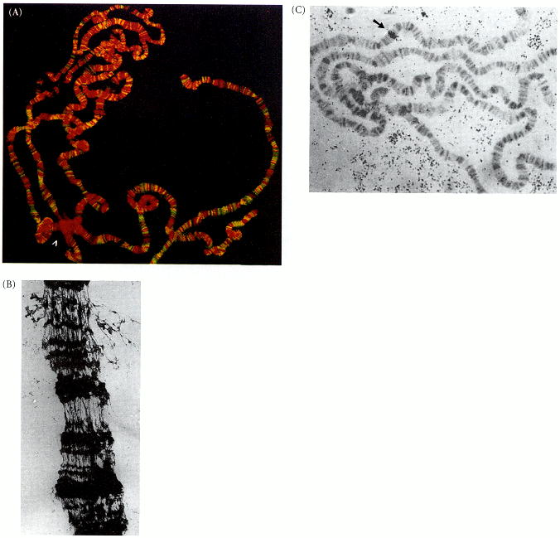

Figure 4.13. Polytene chromosomes. (A) Polytene chromosomes from the salivary gland cells of Drosophila melanogaster. The four chromosomes are connected at their centromere regions, forming a dense chromocenter (arrowhead). The DNA has been stained red with propidium iodide stain. The yellow stain represents the binding of a particular protein to the DNA. This protein is involved in compartmentalizing the regions of the chromosome so that the activation of one gene does not cause the activation of its neighbors. (B) Electron micrograph of a small region of a Drosophila polytene chromosome. The bands (dark) are highly condensed compared with the interband (lighter) regions. (C) Hybridization of a yolk protein mRNA with the polytene chromosome of a larval Drosophila salivary gland. The dark grains (arrow) show where the radioactive yolk protein message has bound to the chromosomes. Note that the gene for the yolk protein is present in the salivary gland chromosomes, even though yolk protein is not synthesized there. (A courtesy of U. K. Laemmli; B from Burkholder 1976, courtesy of G. D. Burkholder; C from Barnett et al. 1980; photograph courtesy of P. C. Wensink.)

